AWS App Runner
What is AWS App Runner?
AWS App Runner is an AWS service that provides a fast, simple, and cost-effective way to deploy from source code or a container image directly to a scalable and secure web application in the AWS Cloud. You don't need to learn new technologies, decide which compute service to use, or know how to provision and configure AWS resources.
App Runner connects directly to your code or image repository. It provides an automatic integration and delivery pipeline with fully managed operations, high performance, scalability, and security.

Pricing for App Runner
App Runner provides a cost-effective way to run your application.
you are charged for the compute and memory resources used by your application. In addition, if you automate your deployments, you will pay a set monthly fee for each application that covers all automated deployments for that month. If you opt to deploy from source code, you will pay a build fee for amount of time it takes App Runner to build a container from your source code.
- Provisioned container instances
$0.007 / GB-hour*
When your application is deployed, you pay for the memory provisioned in each container instance. Keeping your container instance's memory provisioned when your application is idle ensures it can deliver consistently low millisecond latency
* The pricing of $0.007 / GB-hour is applicable for the following AWS Regions: US East (N. Virginia), US East (Ohio), US West (Oregon), and Europe (Ireland). For the Asia Pacific (Tokyo) Region, pricing is $0.009 / GB-hour.
- Active container instances
$0.064 / vCPU-hour*
$0.007 / GB-hour*
When your application is processing requests, you switch from provisioned container instances to active container instances that consume both memory and compute resources. You pay for the compute and any additional memory consumed in excess of the memory allocated by your provisioned container instances. App Runner automatically scales the number of active container instances up and down to meet the processing requirements of your application. You can set a maximum limit on the number of active container instances your application uses so that costs do not exceed your budget. When your active container instances are idle, App Runner scales back to your provisioned container instances (the default is 1 provisioned container instance).
All container instance processing is billed per second, rounded up to the next nearest second. There is a one minute minimum charge for vCPU resources every time a provisioned container instance starts processing requests.
* The pricing of $0.007 / GB-hour and $0.064 / vCPU-hour is applicable for the following AWS Regions: US East (N. Virginia), US East (Ohio), US West (Oregon), and Europe (Ireland). For the Asia Pacific (Tokyo) Region, pricing is $0.009 / GB-hour and $0.081 / vCPU-hour.
- Automatic deployments
You can choose to opt-in to automatic deployments, a feature that builds a container image following changes in a source code deployment branch and subsequently triggers a deployment.
- Build fee
You will pay a build fee for the amount of time it takes App Runner to build your application from your source code. You pay this build fee only for the first deployment of your application or when there is a change made to the source code.
Configurations for create an App Runner service
- Configure your source code.
- Configure source deployment.
- Configure application build.
- Configure your service.
- Review and confirm.

- On the Source and deployment page, in the Source section, for Repository type, choose Source code repository.
- Select a Provider Type. Choose either GitHub or Bitbucket.
- Next choose Add new. If prompted, provide your GitHub or Bitbucket credentials.
- Choose the next set of steps based on the Provider type you previously selected.

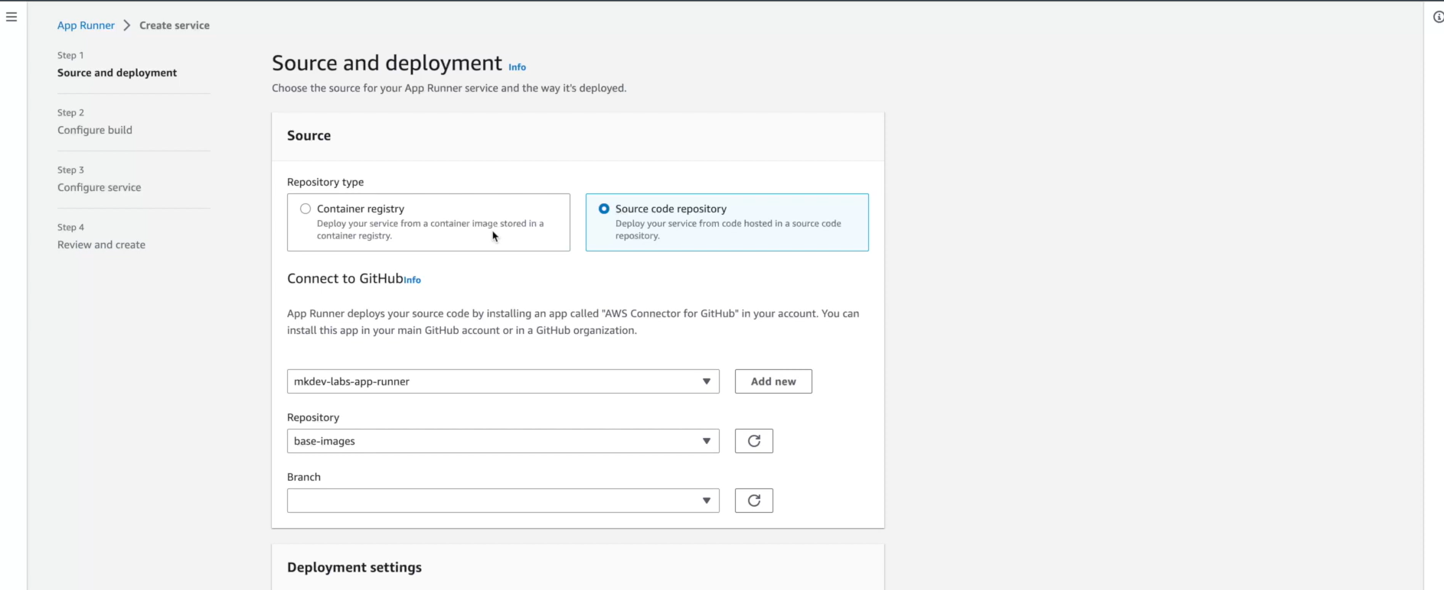
  - Configure application build.
- On the Configure build page, for Configuration file, choose Configure all settings here
  - Provide the following build settings:
Runtime – Choose Python 3.
Build command – Enter pip install -r requirements.txt.
Start command – Enter python server.py.
Port – Enter 8080
Choose Next.
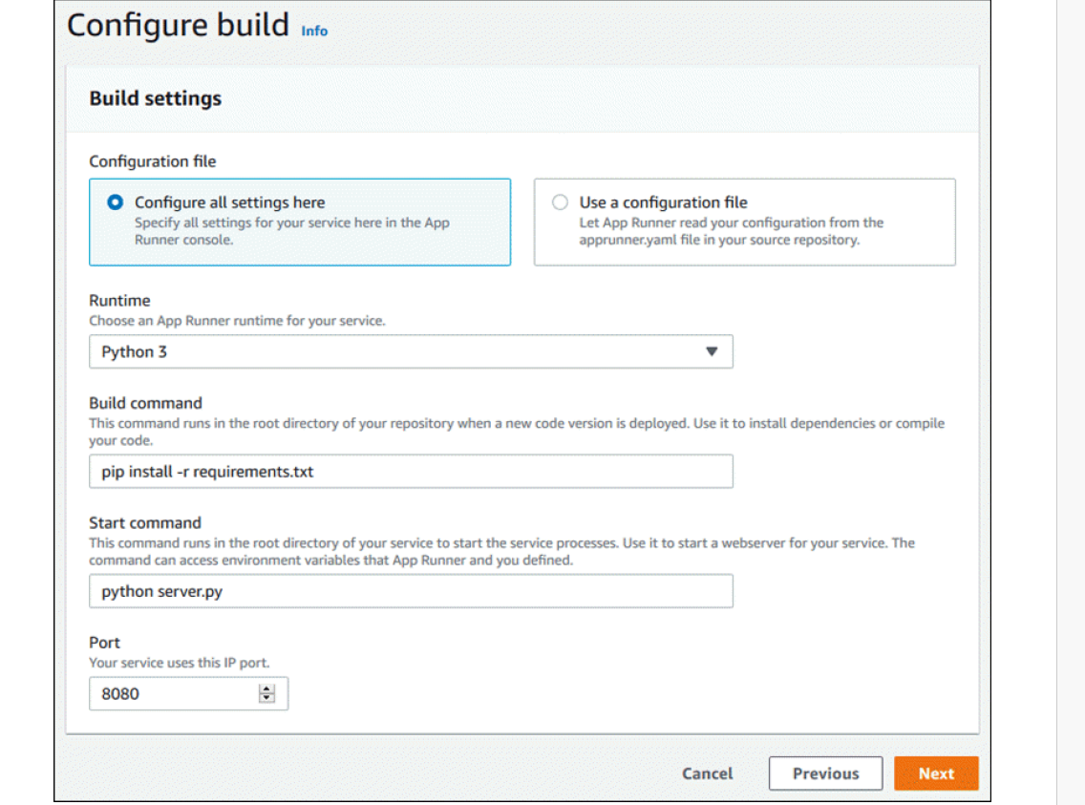

  - Configure your service.
On the Configure service page, in the Service settings section, enter a service name.
  - 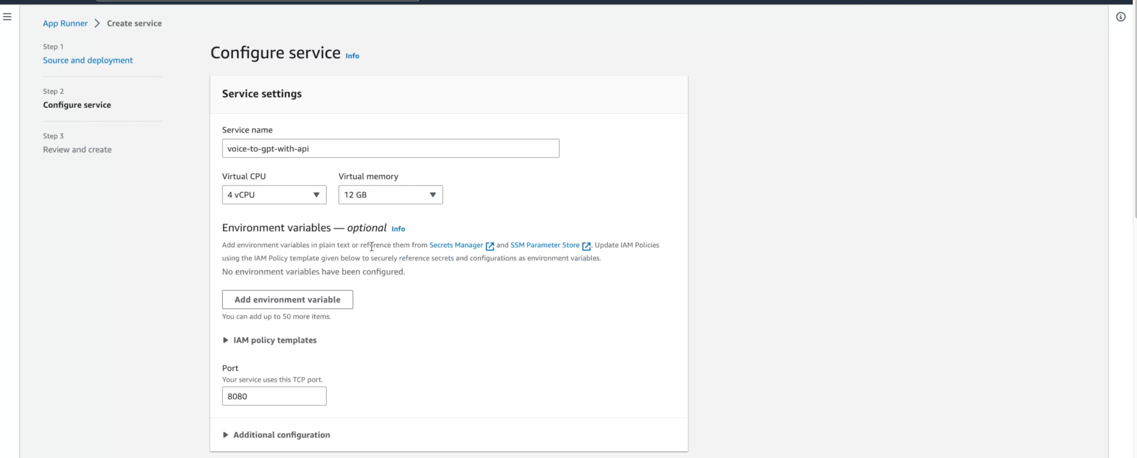

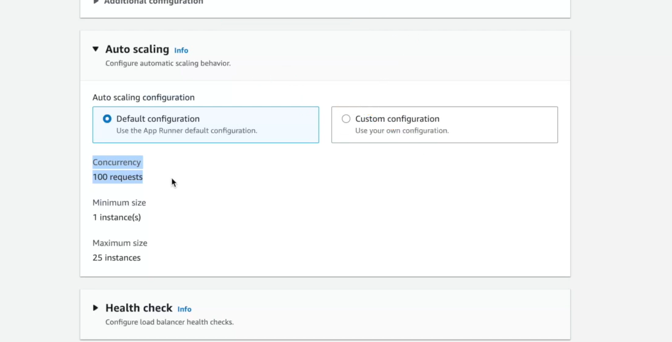

  - On the Review and Create page, verify all the details you've entered, and then choose Create and deploy.
If the service is successfully created, the console shows the service dashboard, with a Service overview of the new service.

AWS App Runner availability change
After careful consideration, we decided to close AWS App Runner to new customers. Existing AWS App Runner customers can continue to use the service as normal, including creating new resources and services. AWS continues to invest in security and availability for AWS App Runner, but we do not plan to introduce new features.
We recommend that customers explore Amazon Elastic Container Service (Amazon ECS) Express Mode when migrating from AWS App Runner. Amazon ECS Express Mode preserves App Runner's operating simplicity while providing access to the broader Amazon ECS feature set. With a single API call, you provide a container image and two IAM roles, and Amazon ECS provisions a complete application stack in your AWS account, including an ECS service on Fargate, an Application Load Balancer, auto scaling, and networking. There is no additional charge for using Amazon ECS Express Mode. You pay only for the underlying AWS resources created to run your application.

- Amazon ECS Express Mode
An Amazon ECS Express Mode service reduces the complexity of deploying containerized applications by providing sensible defaults and automating the configuration of supporting AWS services. Instead of managing configuration parameters across multiple services, an Express Mode service requires only three things to get started:
- A container image
- A task execution role
- An infrastructure role
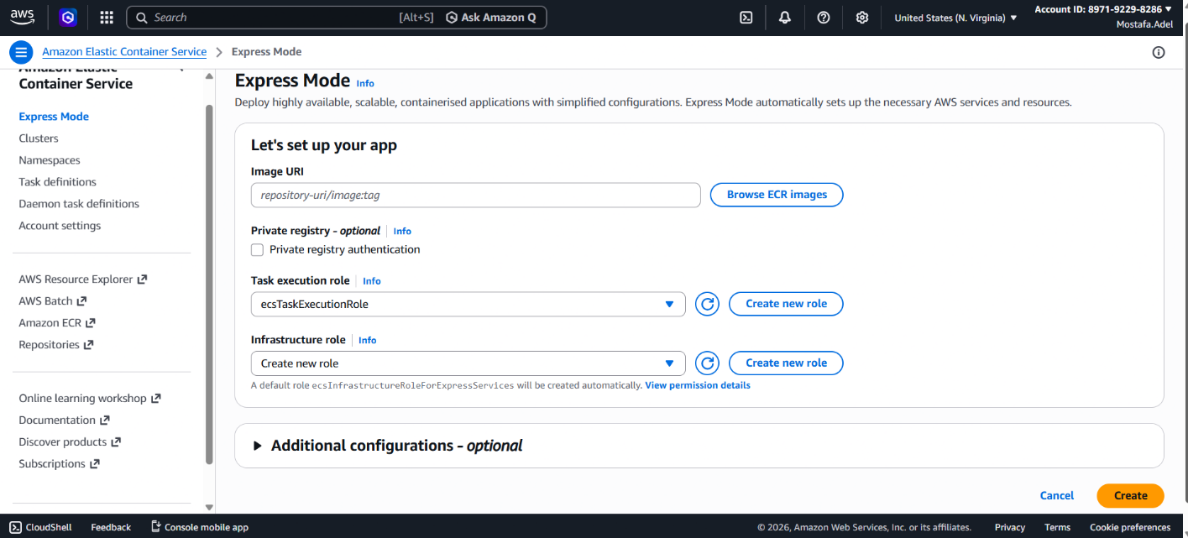

Comparison
